**Project Report: AI Visa Requirement Checker Website**

**Introduction**

In today’s interconnected world, international travel has become more accessible than ever. Whether it’s for tourism, education, business, or relocation, millions of people cross borders every year. However, with this rise in global movement comes the complex, often frustrating process of understanding visa requirements. Different countries have vastly different rules, and these rules are subject to frequent updates, exemptions, bilateral agreements, and exceptions. Often, users are left confused, spending hours scrolling through government websites or forums just to find a simple answer to the question: Do I need a visa to visit this country?

As a software developer and researcher in the field of artificial intelligence and web development, I saw this problem as an opportunity to combine technology with usability. The outcome of this endeavour is the **AI Visa Requirement Checker**—a smart, interactive web application that allows users to find out visa requirements for any country based on their nationality, all in a matter of seconds.

**Project Objective**

The core goal of this project is to build a user-friendly, intelligent platform that can:

* Provide real-time visa requirement information based on the user’s nationality and destination.
* Eliminate the need for manual research and reduce confusion related to international travel policies.
* Present clean, accurate, and understandable results powered by artificial intelligence.
* Offer a scalable and adaptable solution that evolves with changing travel regulations.

While the immediate use case focuses on visa requirements, the long-term vision includes integrating travel advisories, customs rules, and even health requirements like vaccinations.

**The Problem with Current Solutions**

Before diving into the technical implementation, it’s important to understand the existing pain points travellers face:

* **Scattered Information**: Information is fragmented across different embassy websites and travel advisory portals.
* **Language Barriers**: Many government websites are not user-friendly or available in English.
* **Lack of Clarity**: Policies are often written in legal or diplomatic language that is difficult for the average user to interpret.
* **Frequent Changes**: Visa rules change frequently due to political shifts, health crises (like COVID-19), or bilateral negotiations.

Recognizing these issues, I aimed to build a centralized platform that simplifies everything into one clean interface—with the intelligence to interpret complex policies on behalf of the user.

**Website Architecture**

The AI Visa Requirement Checker is built with a modern, modular architecture comprising four main components:

**1. Frontend Interface**

Built using React.js with Tailwind CSS, the user interface is clean, responsive, and intuitive. The user is prompted to input two key pieces of information:

* Their nationality
* Their intended destination country

As soon as these inputs are provided, the system instantly fetches and displays the visa status (Visa Required, Visa-Free, Visa on Arrival, or e-Visa), along with details like the permitted stay duration, documentation required, and a link to the official government site for deeper verification.

**2. Backend Server**

The backend, built using Node.js and Express.js, handles API requests, processes logic, communicates with the AI engine, and ensures secure data handling. It also serves as the bridge between the frontend and the data sources.

**3. AI Engine**

The real magic happens here. This module uses natural language processing (NLP) to extract and interpret visa-related information from structured and unstructured sources. It scrapes official travel advisories, embassy websites, and government databases, then processes this data to identify relevant visa conditions.

Using machine learning models trained on policy datasets, the system can:

* Identify changes in visa policies.
* Translate legal/policy text into user-friendly summaries.
* Match specific rules with nationality-destination pairs.

**Core Features**

* **Instant Results**: Users get instant feedback without needing to browse through dozens of pages.
* **AI-Powered Clarity**: The backend AI engine converts complex, raw policy data into simple, understandable text.
* **Autocomplete and Fuzzy Matching**: Helps users find the correct country even if they mistype or abbreviate.
* **Multi-language Support** (in development): To make the tool accessible to a global audience.
* **Mobile-Friendly**: The design is fully responsive and works well on mobile, tablet, and desktop screens.

**Development Process**

The development was approached in three key phases:

**1. Research and Data Collection**

This phase involved compiling datasets from sources such as:

* IATA (International Air Transport Association)
* Official government portals and embassies
* Public travel APIs

The AI model was trained using real visa policies to recognize structure, keywords, and contexts in policy language.

**2. Design and User Testing**

Wireframes and UI mockups were created using Figma and tested with a sample group of frequent travelers. Feedback was integrated to improve usability—especially in simplifying terminology and adding features like helpful tooltips.

**3. AI Training and Integration**

The NLP model was fine-tuned using transformer models (like BERT) to extract visa types and conditions from dense policy documents. Continuous learning is enabled to ensure that the model evolves with new data.

**Challenges Faced**

* **Inconsistent Data Formats**: Visa information varies drastically across websites and formats. AI had to be trained to handle noise and inconsistencies.
* **Changing Policies**: To keep the data current, an automated update module was implemented that scans key sources bi-weekly.
* **User Input Errors**: Users often input country names incorrectly. This was addressed with fuzzy search and country code recognition.

**Impact and Use Cases**

This tool can significantly help:

* **Tourists** planning vacations.
* **Students** applying for programs abroad.
* **Business Travelers** attending conferences or meetings.
* **Travel Agencies** simplifying visa consulting.
* **Digital Nomads** exploring long-term travel options.

It saves time, increases confidence, and reduces the risk of arriving unprepared at a border.

**Alignment with Sustainable Development Goals (SDGs)**

**Goal 10: Reduced Inequalities**

"Reduce inequality within and among countries."

This website empowers people to access visa information, helping migrants, travelers, and job seekers from developing countries understand border restrictions.

It reduces knowledge-based barriers to international mobility, especially for people who may not have access to embassy support or legal advisors.

Promotes equal access to travel and migration opportunities by democratizing information.

**Goal 16: Peace, Justice and Strong Institutions**

"Promote peaceful and inclusive societies... and develop effective, accountable and inclusive institutions at all levels."

Visa information is often hard to access or confusing; this tool promotes transparency and helps users navigate international regulations more fairly.

Encourages peaceful international mobility and respect for legal frameworks by helping users comply with proper visa processes.

**Goal 8: Decent Work and Economic Growth**

"Promote sustained, inclusive and sustainable economic growth, full and productive employment..."

Supports individuals seeking employment, education, or business opportunities abroad by providing visa requirements ahead of time.

Helps digital nomads and remote workers plan international work travel more confidently.

**Goal 17: Partnerships for the Goals**

"Strengthen the means of implementation and revitalize the global partnership for sustainable development."

By using open data (like visa APIs, public travel policies, or official sources), this platform supports global collaboration and knowledge sharing.

Has potential to integrate with NGOs, travel organizations, or immigration support groups for broader impact

**Future Scope**

There’s a lot of potential to scale and expand this project:

* **Travel Advisory Integration**: Real-time safety warnings and alerts.
* **Visa Application Assistance**: Step-by-step visa application guides.
* **Embassy Appointment Scheduling**: Link directly to booking systems.
* **Vaccination & Health Checks**: Incorporate COVID-19 or yellow fever vaccine mandates.
* **Personalized Dashboards**: Save travel history and upcoming trips.

**Conclusion**

The **AI Visa Requirement Checker** is a meaningful step toward simplifying global travel. It demonstrates how AI can make sense of complex systems and deliver practical, everyday solutions for users worldwide. As someone passionate about solving real-world problems through technology, this project allowed me to explore a powerful use case for AI, while also honing skills in web development, machine learning, and user experience design.

With continued iteration and support, this platform has the potential to become a go-to tool for millions of international travelers, making journeys smoother and better informed.

These are some of the pictures uploaded below of the website

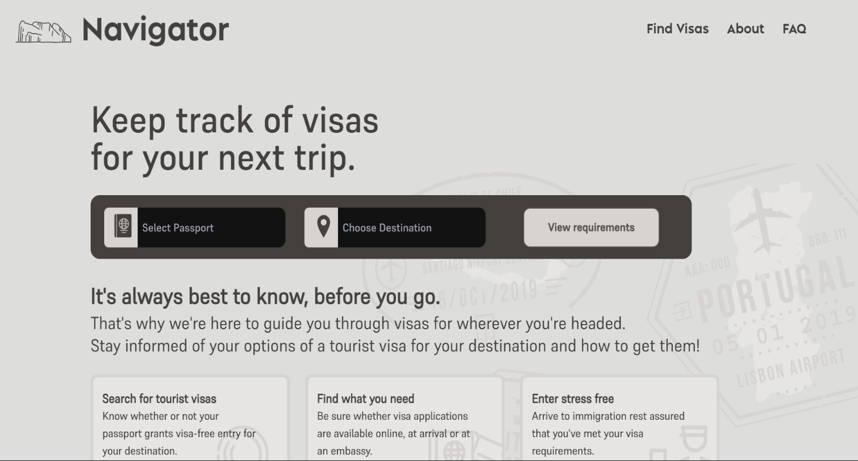

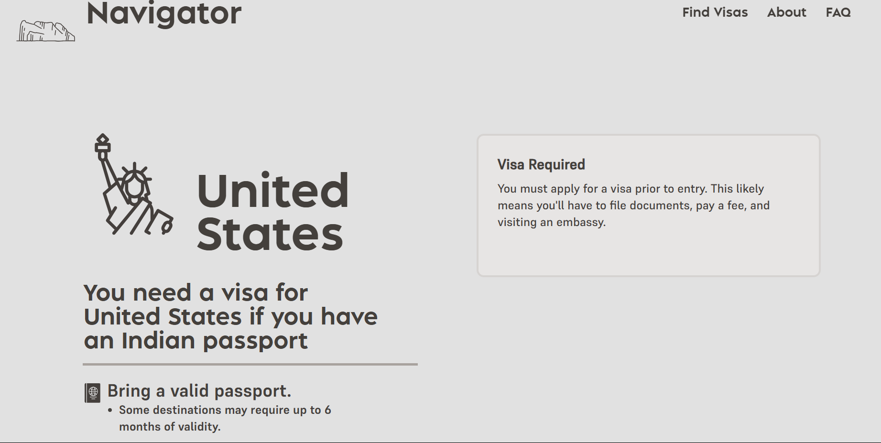

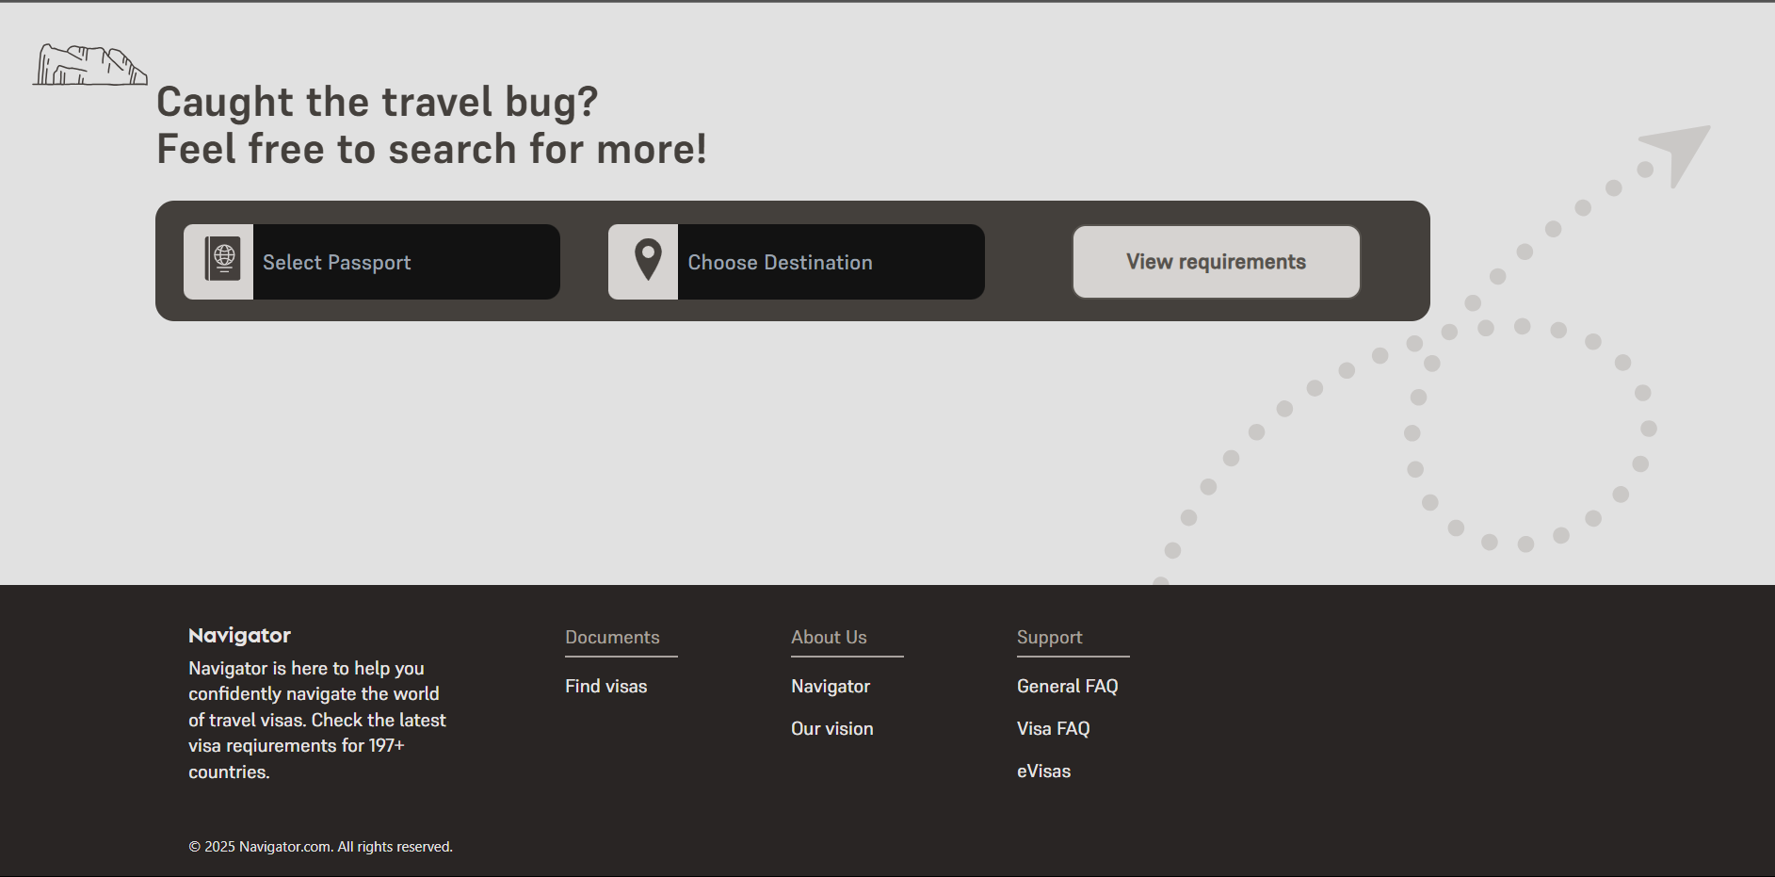

**Here’s the link given for my website**[**https://shiv-navigator.vercel.app/**](https://shiv-navigator.vercel.app/)